Ideation Phase
Define the Problem Statements

Date | 09 February 2026
Team ID | LTVIP2026TMIDS86901
Project Name | ToyCraft Tales: Tableau's Vision into Toy Manufacturer Data
Maximum Marks | 2 Marks

Customer Problem Statement Template:
Problem Statement – 1: THE CAR BUYER
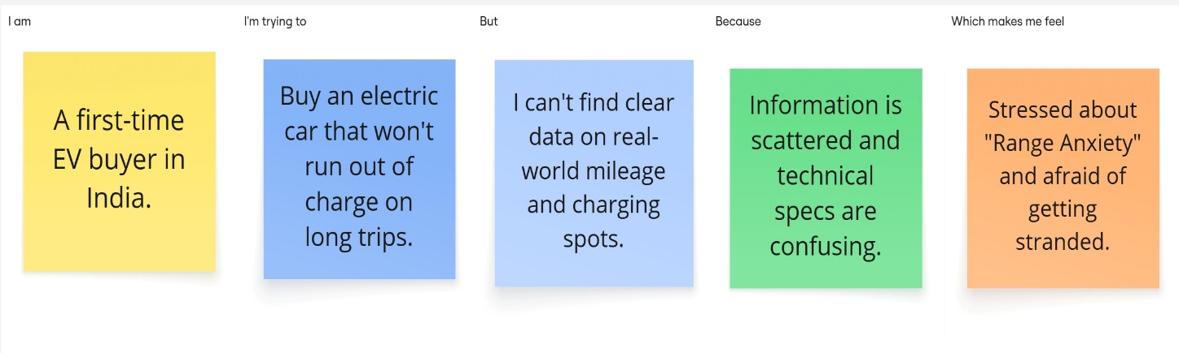

Problem Statement – 2: THE BUSINESS PLANNER
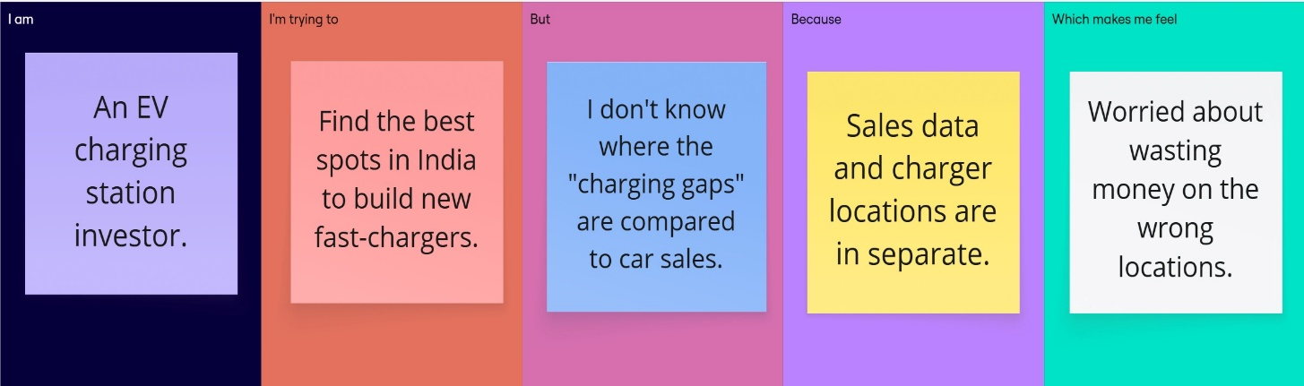
Problem Statement (PS) | I am (Customer) | I’m trying to | But | Because | Which makes me feel
The Car Buyer | A first-time EV buyer in India. | Buy an electric car that won't run out of charge on long trips. | I can't find clear data on real-world mileage and charging spots. | Information is scattered and technical specs are confusing. | Stressed about "Range Anxiety" and afraid of getting stranded.
The Business Planner | An EV charging station investor. | Find the best spots in India to build new fast-chargers. | I don't know where the "charging gaps" are compared to car sales. | Sales data and charger locations are in separate. | Worried about wasting money on the wrong locations.

